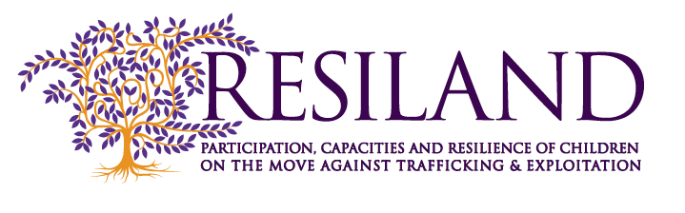
Round Table Meeting Agenda
Monday, 19 October 2015 | Brussels, NH Hotel Grand Place Arenberg
08:45 | Registration
09:00 | Welcome  Daja Wenke, Member of the Resiland Advisory Group  Marily Mexi, Social Policy Expert, KMOP, Greece
09:45 | Core Findings of RESILAND project  Pippo Costella, Director, Defence for Children International – Italy
10:00 | Results and lessons learned from the national consultations  - Bénédicte Cabrol, Hors La Rue, France  - Marily Mexi, KMOP, Greece  - Júlia Pàmias, Defence for Children International – Italy  - Ana Cardoso, CESIS, Portugal
10:45 | Coffee break
11:00 | RESILAND Video
11:30 | Thematic Briefings  Moderator: Pippo Costella, Director, Defence for Children International – Italy  - The ‘principle of participation’ and the UN Convention on the Rights of the Child  Virginia Murillo Herrera, Executive President, Defence for Children International, Costa Rica  - Elements of child trafficking in the children’s narration  Philip Ishola, Independent Child Protection, Human Trafficking, Human Rights Consultant, UK  - Promoting participation and protection through guardianship systems  Renate van Loon, Nidos, Netherlands  - Participation as a means of empowerment and prevention of children going missing  Delphine Moralis, Secretary General, Missing Children Europe
12:30 | Presentation of the RESILAND Safety Map and Orientations for Professionals  Moderator: Pippo Costella, Director, Defence for Children International – Italy  - Júlia Pàmias, Defence for Children International – Italy  - Daja Wenke, Independent Researcher and Consultant, Child Rights, Member of the Resiland Advisory Group
13:00 | Lunch Break
14:30 | Interventions by Professionals Working With and for Children on the Move  Moderator: Virginia Murillo Herrera, Executive President, Defence for Children International, Costa Rica  - Noémia Bandeira dos Santos Gomes, National Committee for the Protection of Children and Young People at Risk, Portugal  - Juri Pertichini, Social Worker, Italy  - Nagham Hriech Wahabi, Organisation Internationale Contre l'Esclavage Moderne, France  - Christos Dimopoulos, Head of the Housing Management Service for Asylum Seekers and Unaccompanied Juveniles, Division of Social Intervention of the National Centre for Social Solidarity, Ministry of Labour Social Security and Welfare, Greece  - Sara Gil Marrodán, Social Intervention Technician and Conflicts Mediator, Emancipation Programme for Young People at Risk, Red Cross, Spain  - Elodie Antony, Project Officer, Swiss Foundation of the International Social Service, Switzerland
15:30 | Coffee break
15:45 | Round-Table Discussion  Moderator: Philip Ishola, Independent Child Protection, Human Trafficking, Human Rights Consultant, UK  - Miguel Coelho, Office of the Ombudsman for Children, Portugal  - Stefania Pizzolla, National Authority for Children and Adolescents, Italy  - Elin Wernqvist Roberts, Secretary General, Children’s Rights Bureau, Stockholm, Sweden  - Ariane Couvreur, ECPAT Belgium  - Anastasia Anthopoulos, Programme Officer, International, Oak Foundation
17:00 | Closure

